Project Design Phase
Solution Architecture

Date | 31 August 2026
Project Name | Automated Network Request Management in ServiceNow
Maximum Marks | 4 Marks

Solution Architecture:
he solution architecture of Automated Network Request Management in ServiceNow shows how users, ServiceNow applications, automation, and data work together to manage network requests. Employees submit requests through the Service Catalog, where the required information is captured using dynamic forms. Flow Designer automates record creation, approval, assignment, status updates, and notifications. Approved requests are processed by the Network Support Team, while request information is stored in ServiceNow tables for tracking and reporting.

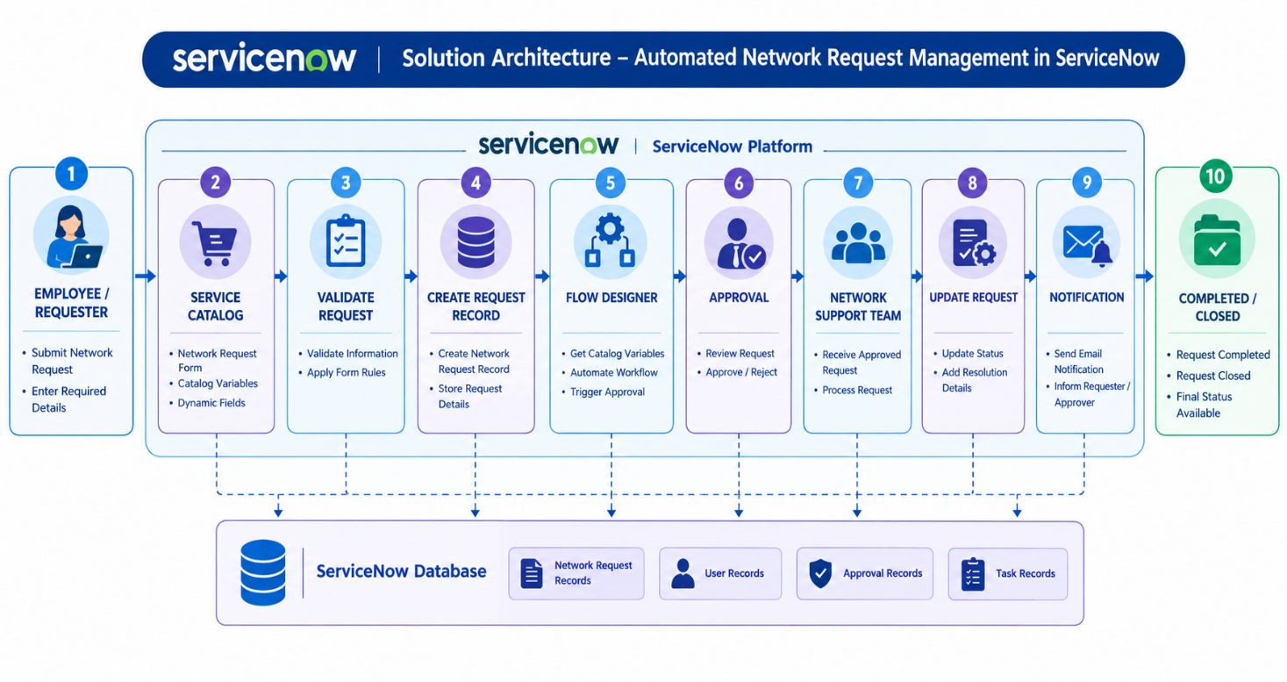

Architecture Flow:
Employee / Requester → Service Catalog → Network Request Form → Flow Designer → Approval → Network Support Team → Request Processing → Status Update & Notification → Request Closure.

Key Components:
- Employee / Requester – Submits and tracks network requests.
- Service Catalog – Provides the network request form.
- Client Scripts & UI Policies – Control dynamic fields and form behavior.
- Flow Designer – Automates the request workflow and approvals.
- Approval Management – Handles approval or rejection of requests.
- Network Support Team – Processes approved requests.
- ServiceNow Database – Stores request, user, approval, and task information.
- Notifications – Sends updates to users and approvers.
- Reports – Helps administrators monitor network requests.

